# Lab 14. Application Lifecycle Management Light

**Learning objective:** a good practice in programming is to be able to reuse code. Creating reusable and generic flow is a great way to reuse code and to make your code more robust. Child flow are part of the standard Power Platform license and does not require a premium license.

**Duration:** 30 minutes

**Scenario:** we will create a flow that will retrieve information from a SharePoint list and from an excel file. In order to make this flow easier to be deployed across several environment we will dynamically provide the list and file url. We will create a child flow that will retrieve this information from environment variables. Child flow must be created from a Solution, so you will create a solution as well.

## PART 1. Define the parameters

### Tasks:

1. Make sur you have a premium license; this will be necessary to retrieve Environment variable from a flow ‘see lab0).
2. Switch to your Developer environment

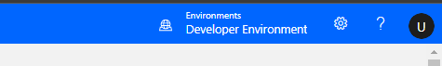

1. Go to Solutions and create a new solution from scratch; if requested click **Create a database**.

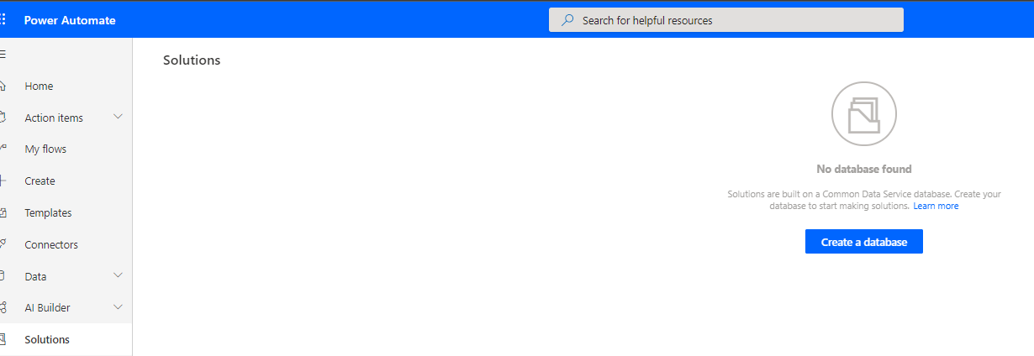

1. Fill in the database properties and click **create my database**:

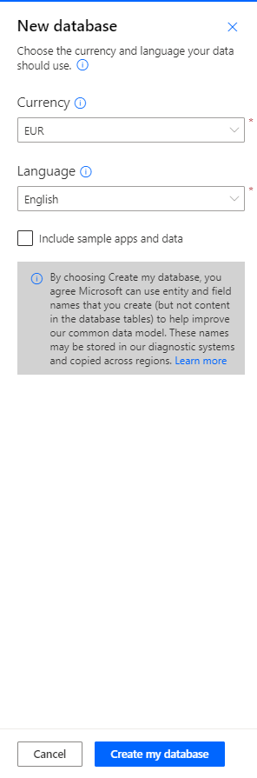

Wait a couple of minutes for the database to be created.

Click New Solution

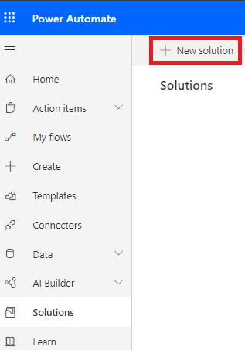

Fill-in the solution properties and under Publisher click + Publisher:

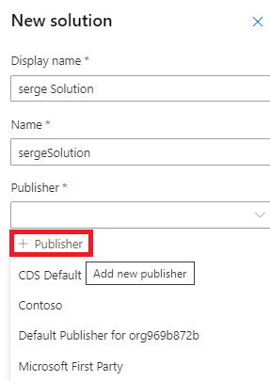

In the next windows, replace the existing publisher with a new one by clicking on **+ Publisher**:

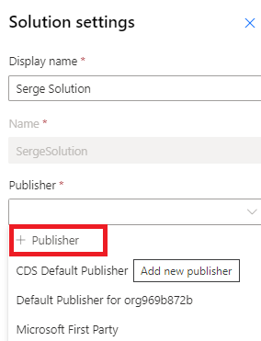

1. A new window will pop up where you can select a new Display Name like **Contoso** and a prefix like **conto**:

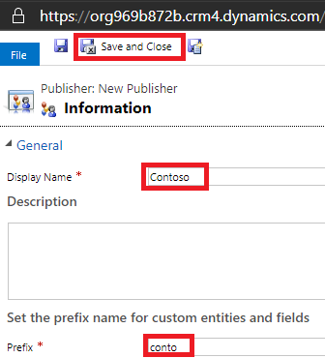

Select **Contoso** as the new publisher and click Update:

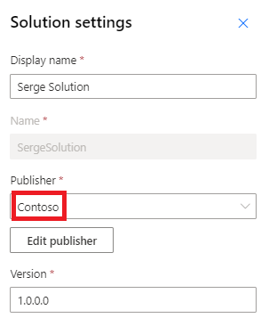

1. Click Create:

Click your solution and create a Flow that is started manually and that connects to a SharePoint list and to an Excel document with a table:

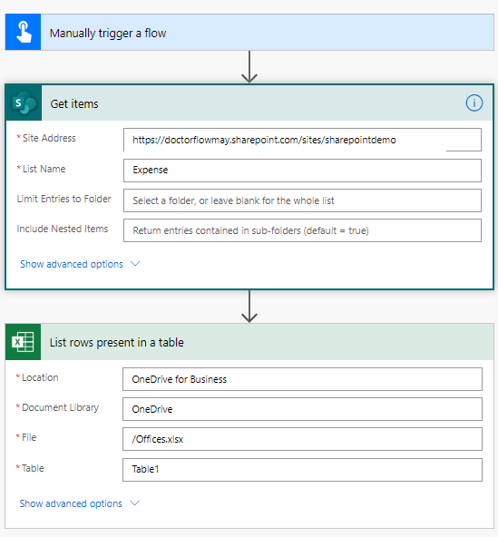

Enterprise flows can have many actions and deploying these flows from different environments (DV, TEST, PROD) can quickly become a nightmare.

The first option is to create a new Compose called DEVParams that will contain the internal references:

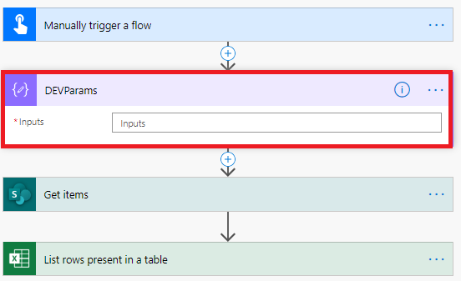

To retrieve the references, you need to click the Peek code option of the action:

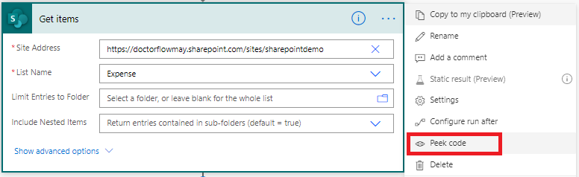

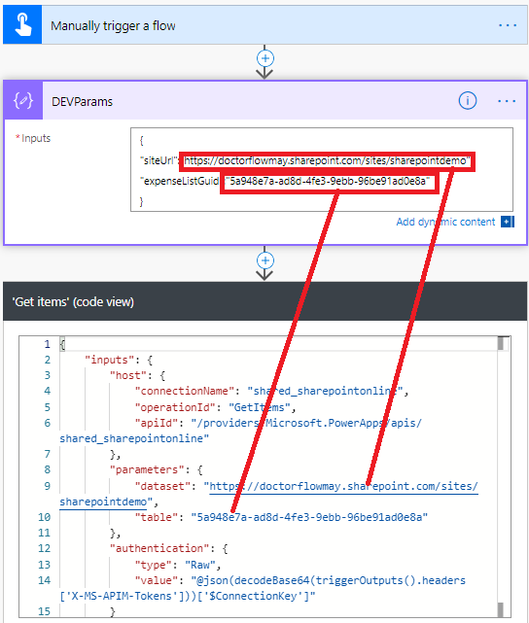

Proceed like this to retrieve the references used by the Excel action :

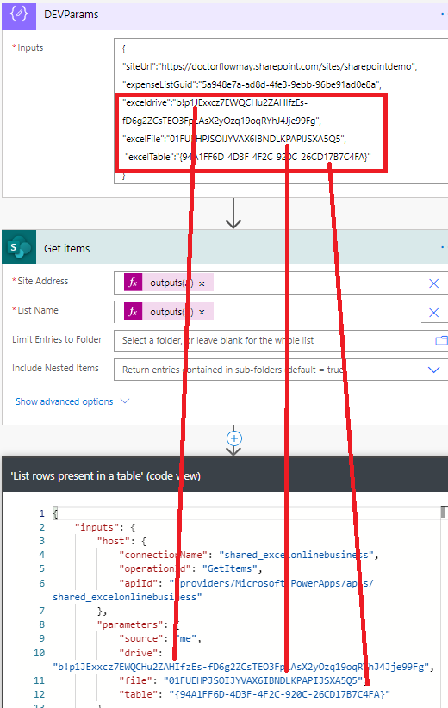

We need to use dynamic properties to use these references in our code. Add a Parse JSOn action and rename it **Params**:

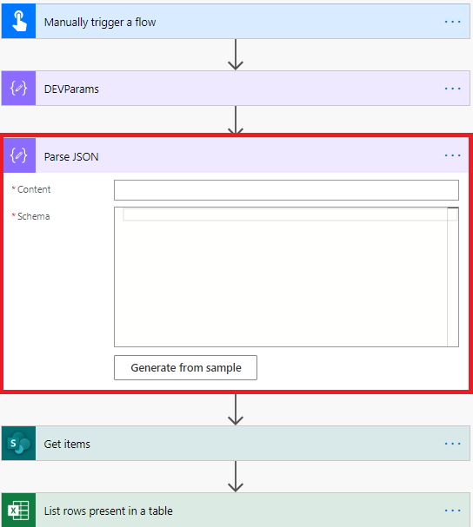

Copy the JSOn information from the action DEVParams and click **Generate from sample**, paste the info in there:

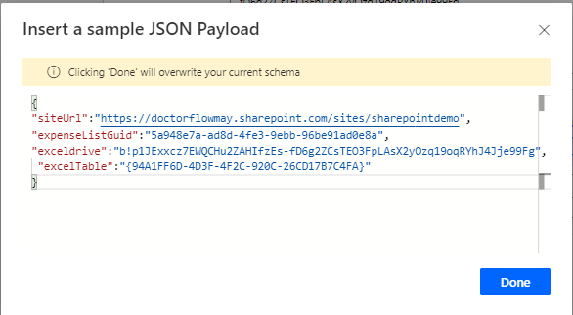

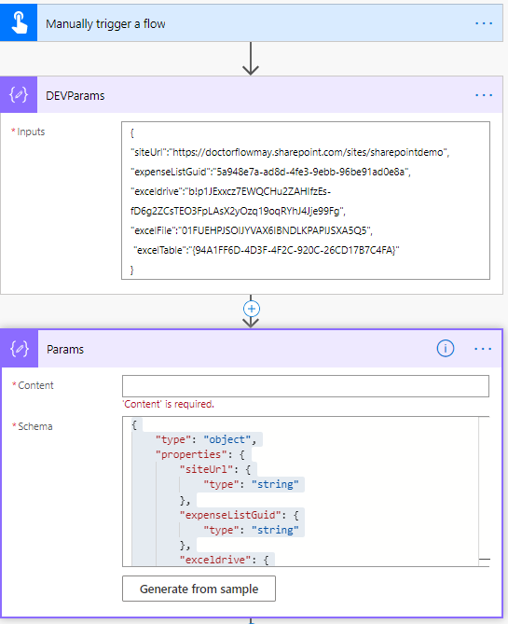

Use DevParams output in Params content:

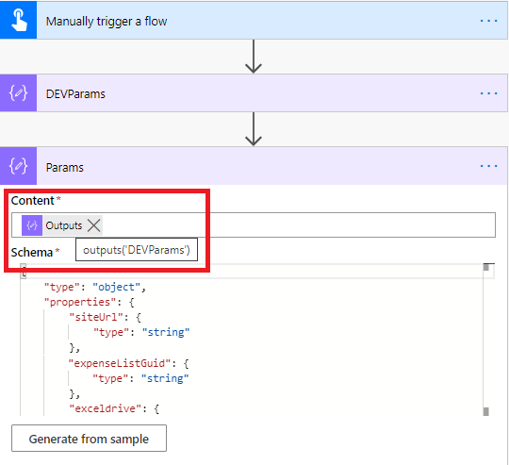

Replace the reference in the SharePoint and Excel actions with dynamic value. Now if you need to deploy your flow to another environment (like another SharePint Test site), you can create a new Compose object named TESTParams with the reference in test. And you just bind Params with TESTParams. Test your flow, it should still be working.

PART 2. Use environment variables

This JSOn information can be stored in an environment variables. In the next part we will create a child flow that will retrieve this information from environment variables.

Tasks:

1. Click your solution, select New and create an environment variable:

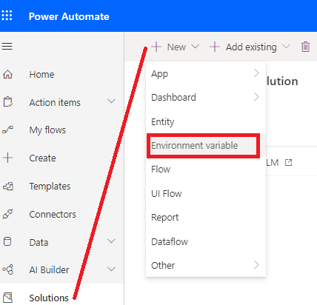

Name the environment variable “PARAMS” and select the Data type JSON and store the JSON data stored in the action DEVParams and click Save:

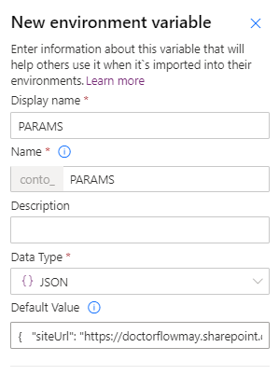

We now need to dynamically retrieve this information from our flows. From the solution create new flow and named it “Find Params”. The trigger should be the “Manually trigger a flow” trigger. Add a first parameter called Environment variable:

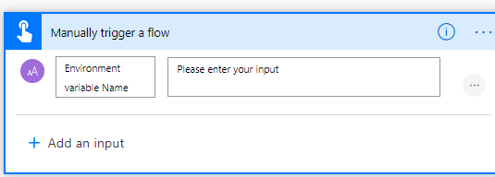

Add an action **List records** from the Common Data Service (current environment) connector:

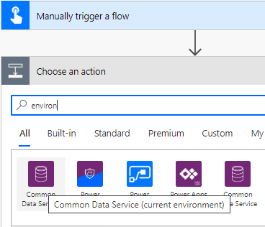

Rename the action as **List records - Find Environment variable definition**

In the filter **Query propery**, filter on *schename eq ‘<your environment variable name>*’:

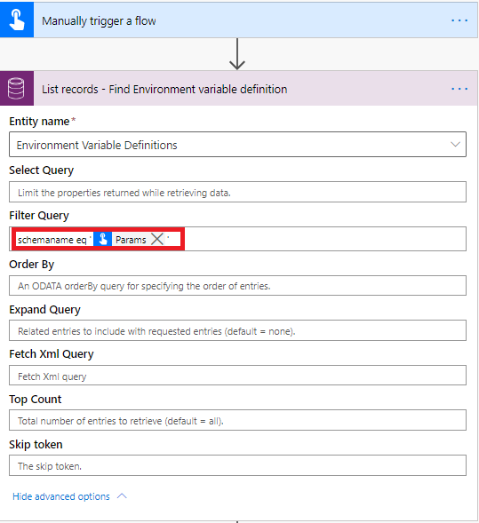

Add a **Compose** action and name it **ParamsValue** :

Set its value to

outputs('List_records_-_Find_Environment_variable_definition')?['body']?['value']?[0]?['defaultvalue']

Add a **Respond to a PowerApps or flow** action to return the **ParamsValue**:

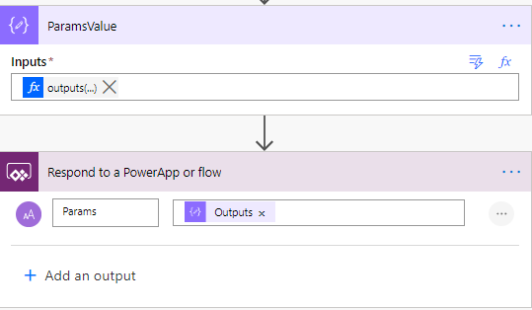

You will now call his flow from the flow you created in part 1 of this lab. Edit the flow

and add a Run a child flow action

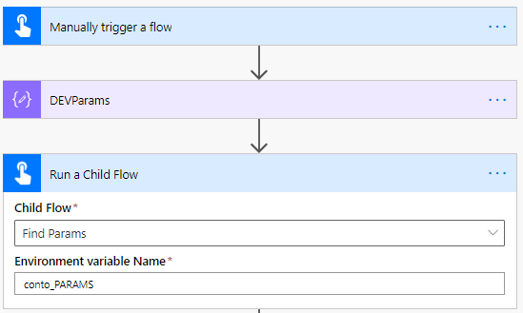

In the Params action, grab the returned value of Run a child flow :

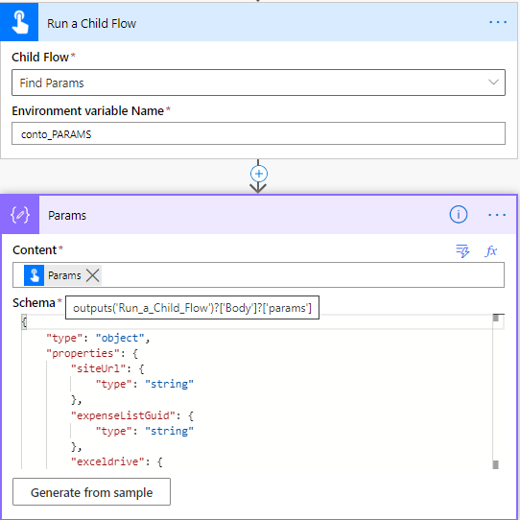

Test your flow.

The Action **DEVParams** can now be removed.

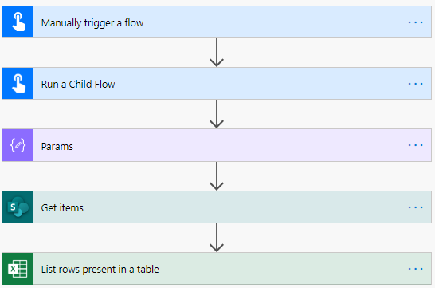

As a good practice we can group Run a child flow and Params in a **scope** called **ALM**:

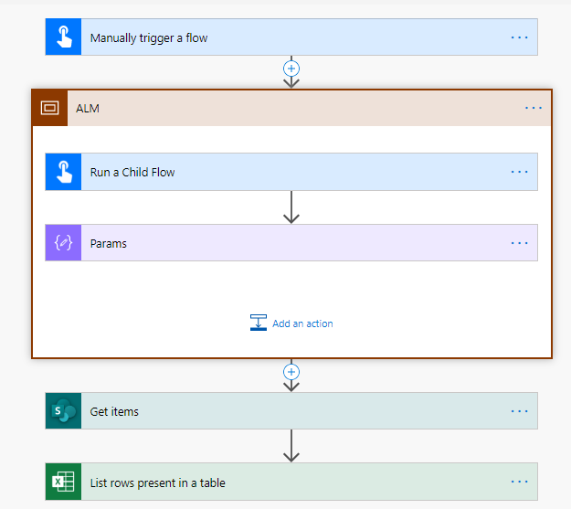

## We need your feedback

Do you want to report an issue or to suggest something? We need your feedback: <https://github.com/Power-Automate-in-a-day/Training-by-the-community/issues>